Week 12. Elevator Four (with direction)
Make a copy of your Elevator Three project and name it Elevator Four. Add two pushbuttons and pixels as in the figure below. Please review this video demonstration of the completed project.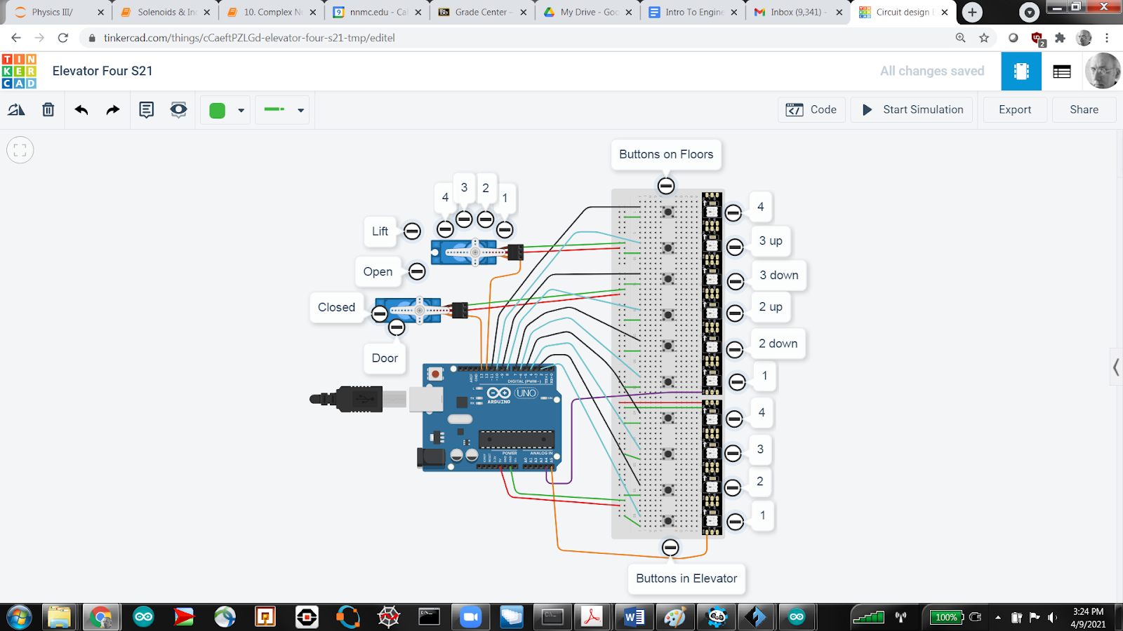
In the revised preamble, make sure to tell Flights that it now has 6 pixels.
I also recommend that you divide our old Fpb into its up and down buttons
int FpbUp[] = {6, 8, 10};
int FpbDown[] = {7, 9, 11};

int Ecall[] = {0, 0, 0, 0},
FcallUp[] = {0, 0, 0},
FcallDown[] = {0, 0, 0};

1. In the setup() function be sure to declare the pinMode for each pushbutton.

2. Upgrade your getFlist() helper function to toggle the correct call list and turn on the correct pixel. (Up pixels are even, Down pixels are odd)

3. In the loop() function

- getFlist();
- Going up? Ascend, using a for loop, through the i=0, 1, 2, checking if FcallUp[i] or Ecall[i] is 1, and taking appropriate actions.
- Going down? Descend, using a for loop, through i=3, 2, 1, checking if FcallDown[i-1] or Ecall[i] = 1 and taking appropriate actions.

